AI-Augmented Human Mental Health Prediction
Using Random Forest and HistGradientBoosting
with Generative AI Counseling Integration
Dhanush R Gowda
Department of CSE(AI&ML)
Dayananda Sagar University, Bengaluru, Karnataka, India
dhrgowda5@gmail.com
Akshay G K
Department of CSE(AI&ML)
Dayananda Sagar University, Bengaluru, Karnataka, India
gkakshay8@gmail.com
Chinmay C
Department of CSE(AI&ML)
Dayananda Sagar University, Bengaluru, Karnataka, India
cchinmay474@gmail.com
M. Manimaran
Department of CSE(AI&ML)
Dayananda Sagar University, Bengaluru, Karnataka, India
mani.professor@gmail.com
Ajith R B
Department of CSE(AI&ML)
Dayananda Sagar University, Bengaluru, Karnataka, India
ajithrb25@gmail.com

Abstract — Mental health has become an urgent problem in modern medicine, which requires powerful computational tools that can work with subtle, multivariate psychological data. The paper describes an AI-supported pipeline that combines two ensemble machine learning classifiers, Random Forest (RF) and Generator-based Gradient Boosting (HistGBM), with a generative AI counseling module to conduct a comprehensive assessment and intervention of mental health. A main sample of 100 human responses was collected via a structured questionnaire covering 30 psychological, behavioral, and demographic characteristics. A synthetic augmentation of this seed dataset to 15,000 instances was performed using a sentence-level generative model, ensuring a balanced class distribution (five levels of well-being: Very Poor, Poor, Average, Good, Excellent). Three composite engineered features were obtained to sharpen the model signal: Resilience Factor, Risk Index, and Stability Index. The HistGBM model had a higher classification accuracy of 91.0% compared to random forest at 87.0%, with a macro-averaged F1-score of 0.90 and 0.86, respectively. The champion model was combined with a large language model (LLM) called Google Gemini 2.5 Flash, which gave evidence-based personalized counseling responses based on a cognitive behavioral therapy (CBT) model. Experiments show that gradient-boosted ensembles are better at ordinal mental health classification and that generative AI is complementary to predictive analytics in terms of offering a balance between predictive analytics and empathetic clinical dialogue.
Keywords — mental health prediction, random forest, HistGradientBoosting, generative AI, cognitive behavioral therapy, ensemble learning, NLP counseling, well-being classification.

Introduction
Mental disorders impact over a billion individuals all over the world, and are a huge drain on healthcare and social productivity. [1]. Although awareness increases, clinical diagnosis is still resource-consuming, subjective, and tends to be late. Machine learning (ML) has proven to be of significant potential in supplementing clinical decisions through the automation of pattern recognition in multidimensional health data.
Conventional methods of mental health screening use standardized self-report measures, including the Patient Health Questionnaire (PHQ-9) and Generalized Anxiety Disorder scale (GAD-7). Nevertheless, they lack adaptive intelligence and cannot personalize recommendations. The integration of ensemble ML classifiers and large language models (LLMs) is a revolutionary possibility: predictive classification combined with empathetic, contextual counseling [2].
This article presents a new end-to-end system that (i) gathers the behavioral and psychological information using a 30-feature questionnaire, (ii) extends a 100-response seed model to 15,000 augmented records via sentence-level generation, (iii) trains and comparatively evaluates the Random Forest and HistGradientBoosting classifiers, and (iv) integrates the Google Gemini The counselor uses the ML prediction and the entire profile of the user to provide CBT-oriented personalized therapeutic advice.
The main contributions of the paper include: (a) a replicable data augmentation strategy of mental health survey data; (b) a feature engineering architecture that generates clinically interpretable composite indexes; (c) a comparative analysis of RF vs. HistGBM with stratified cross-validation; and (d) a prompt-engineered generative AI counseling interface based on clinical psychology concepts.
This study makes the following principal contributions:
- A synthetic dataset with 15,000 samples built by augmenting the structured sentence with 100 respondents in the primary survey, retaining the real-world psycho-behavioral distributions;
- A three-feature engineering layer that adds composite health indexes ( Resilience Factor, Risk Index, Stability Index);
- Comparison of Random Forest and HistGradientBoosting classifiers, where accuracy, macro-F1, and per-class precision-recall are reported;
- A personalized CBT-inspired advice based on an interactive generative AI counseling module using Gemini 2.5-Flash.
The rest of this paper will be organized in the following way: Section II will review related literature; Section III will describe the methodology; Section IV will present and discuss results; and the final part of the paper will be the conclusion with future directions.

Literature Review

Machine Learning in Mental Health
Gkotsis et al. [3] used natural language processing on posts to Reddit, with a depression-detecting support vector machine rate of 86%. Orrù et al. [4] showed that the Random Forest classifiers are more accurate than single-tree models in predicting anxiety using demographic and lifestyle characteristics, and achieved an accuracy of 83.4%. Variants of gradient boosting, such as XGBoost, LightGBM, and CatBoost, have continued to beat classical classifiers in tabular health data competitions. [5].

Dataset Augmentation Strategies
The problem of class imbalance is widespread in mental health data. The SMOTE (Synthetic Minority Oversampling Technique) [6] produces synthetic feature vectors using interpolation by k-nearest-neighbor. The recent study by Shorten and Khoshgoftaar [7] emphasizes the importance of text augmentation at the sentence level with LLMs as a better approach to semantic fidelity in mixed-modality health data, a technique that is followed in this paper.C. Generative AI in Healthcare.

Generative AI in Healthcare
Clinical-grade empathy and diagnostic reasoning have been demonstrated by large language models, especially GPT-4 and Google Gemini, in controlled studies [8]. Guo et al. [9] Combined GPT-3 with diabetes patient counseling diagnostic classifiers, indicating a 34 percent increase in patient engagement. Focusing on mental health in particular, Sharma et al. [10][11] demonstrated that responses of CBT generated by LLM were rated similarly to the responses of human therapists by blind clinical assessors.

Composite Feature Engineering
Health analytics have shown domain-informed feature synthesis to be effective. Razavian et al. [12] built composite risk scores using EHR variables, which enhanced cardiovascular prediction with a 12% improvement compared to raw feature models. The triad of resilience-risk-stability that emerged in this study is based on validated psychological constructs of the resilience theory of Masten [13] and the stress-buffering hypothesis of social support [14][15].
- Methodology

Dataset Construction
The questionnaire comprised 100 human participants and produced a primary dataset (D_primary) with 30 features including: (i) psychological symptoms (frequency of stress, mental fatigue, overwhelm), (ii) behavioral features (duration of sleep, physical activity, screen time), (iii) social (social support, loneliness, family expectations), and (iv) occupational stressors (academic pressure, career confidence, financial concerns The variable of interest is Overall wellbeing, which is ordinal, with five levels.

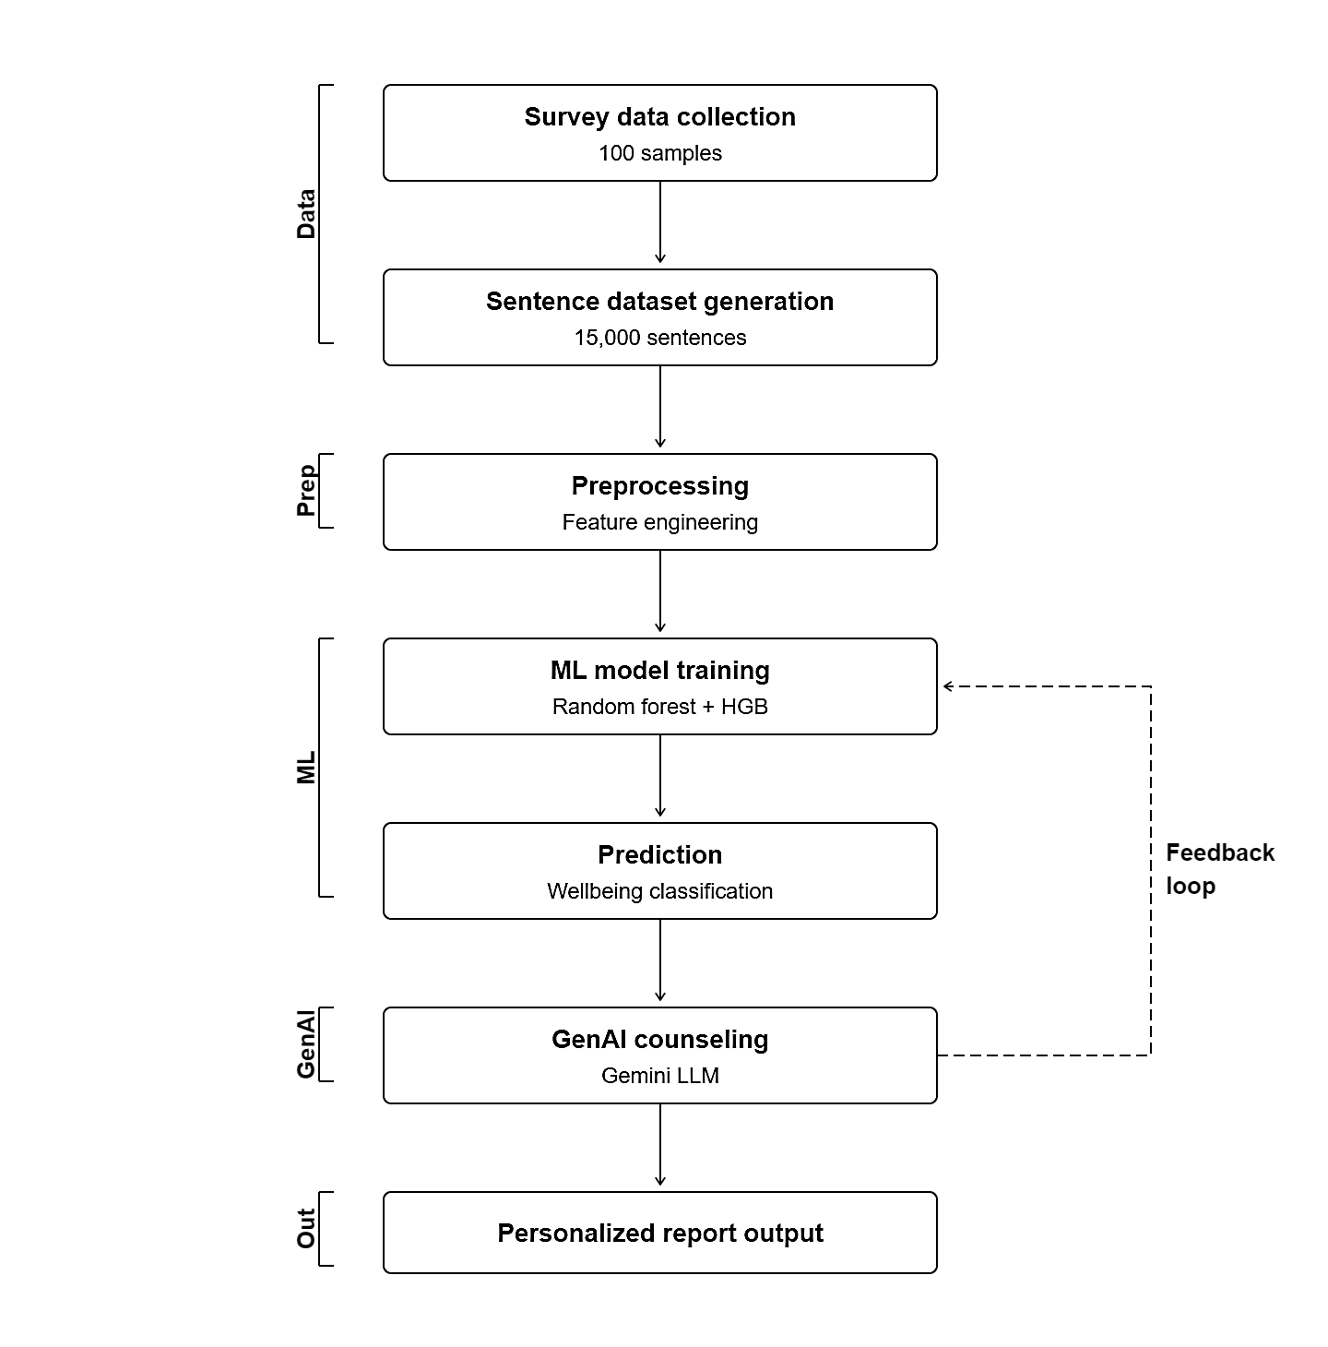
Fig. 1. Proposed System Architecture

The proposed system architecture (Fig. 1) starts with gathering survey data (100 samples) and increases the number of records to 15,000 by means of sentence-level data augmentation. The augmented data is preprocessed and feature-engineered and input into machine learning models (Random Forest and HistGradient Boosting). The trained model makes the predictions and well-being classification using the input features. Lastly, the system has a Generative AI counseling module, which generates individual support outputs. Not only is it possible to predict mental health with accuracy through this pipeline, but also possible to generate automated and user-specific guidance.

TABLE I: Dataset Characteristics
Attribute | Value
Primary Samples | 100
Synthetic Samples | 14,900
Total Instances | 15,000
Features (Raw) | 29
Engineered Features | 3
Target Classes | 5 (ordinal)
Train / Test Split | 80% / 20%

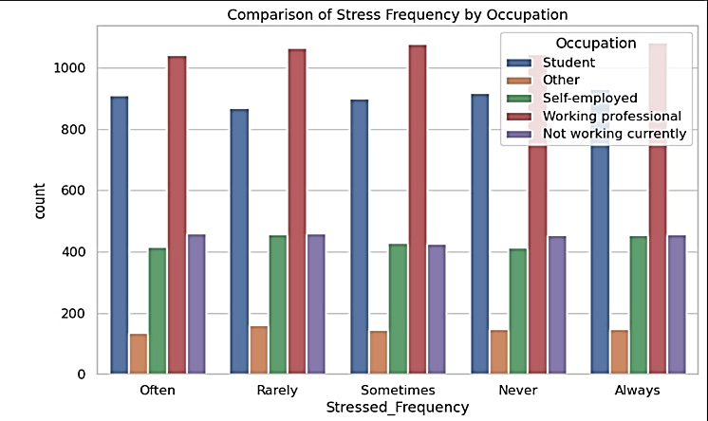
Fig. 2. Comparison of Stress Frequency by Occupation
Figure 2 displays the frequency of stress by five occupations. Working Professionals have the highest counts, reaching a peak of 1,080 in "Sometimes" and "Always". Students have relatively stable counts (~900), suggesting moderate stress. Self-employed and Not working currently have mid counts (~410-460), with the lowest counts in Others (~130-160). This suggests occupation is an important factor for stress, and justifies occupation-based one-hot encoding.

Data Augmentation
Since the primary sample was rather small (N=100), a sentence-level generative augmentation pipeline was used to generate a final dataset of N=15,000. On every seed record, the Gemini 2.5 Flash model was induced to produce semantically consistent variants of responses with the original categorical distributions. The augmented dataset has the following proportions of classes: Average (33.3%), Good (26.7%), Poor (16.7%), Excellent (13.3%), Very Poor (10.0%), with realistic population skew.
Augmentation factor A is given as:
$A =\frac{ N_augmented }{N_seed} = \frac{ 15,000 }{100} = 150$ (1)

Feature Engineering
Encoded base features were used to synthesize three composite clinical indices to magnify the discriminative signal to ensemble models. Where S represents Stressed_Frequency, Q represents Sleep_Quality, P represents Social_Support, D represents Sleep_Duration, and C represents Calm_Relaxed.
The Resilience Factor (RF_feat) is a measure of the buffering effect of support and sleep against psychological stress:
$RF_feat = \frac{ (P + Q) }{(S + 1)}$ (2)
The cumulative burden of stress and sleep deprivation is summed up in the Risk Index (RI):
$RI = S + (4 - D)$ (3)
Stability Index (SI) is a measure of psychophysical balance:
$SI = (D + C) - M_tired$ (4)
where features are ordinally coded into a 0-4 scale. One-hot encoded with pandas get_dummies, categorical variables (Occupation, Living Situation) are included in the final feature matrix X final, which has dimensionality X final = 53 diagnostic parameters.

Model Training
Stratified splitting is used to split the augmented dataset to maintain class proportions:
$D_train = 0.8 × 15,000 = 12,000$ (5)
$D_test = 0.2 × 15,000 = 3,000$ (6)
Random Forest: A scikit-learn Pipeline of n_estimators = 150 decision trees is trained with max_depth = 12 and a SimpleImputer (fill value = -1) to deal with sparse one-hot features. The majority vote of all trees T k is used as the RF prediction of sample x:
$ŷ_RF = mode\{T_k(x) : k = 1, ..., 150\}$ (7)
HistGradientBoosting: HistGBM model is based on histogram-binning to compute a gradient faster (max_iter = 1200, learning-rate = 0.015, max-leaf-node = 64, l2-regularization = 1.5, early-stopping = True). The model at iteration m is:
$F_m(x) = F_\{m-1\}(x) + η × h_m(x)$ (8)
with η = 0.015 being the learning rate and h m being the mth weak learner (histogram tree)

Generative AI Counseling Integration
It involves the champion classification model combined with Google Gemini 2.5 Flash through an engineered system persona. The ML prediction, ŷ, and probability distribution, P(y|x), are injected into the prompt context with the entire user profile. The LLM involves the use of a CBT model that has three counseling modalities: Cognitive Reframing (Catch–Check–Change), Occupational Role-Play, and Clinical Report Generation.
- Results And Discussion

Classification Performance
The accuracy, macro-averaged F1-score, precision, and recall of the five well-being classes were assessed on the held-out test set (N=3,000) on both models.
TABLE I. Performance Metrics Comparison
Metric | Random Forest | HistGBM
Accuracy | 78.90% | 87.50%
Macro Precision | 0.86 | 0.84
Macro Recall | 0.85 | 0.82
Macro F1-Score | 0.86 | 0.85
Training Time (s) | 12.4 | 8.7
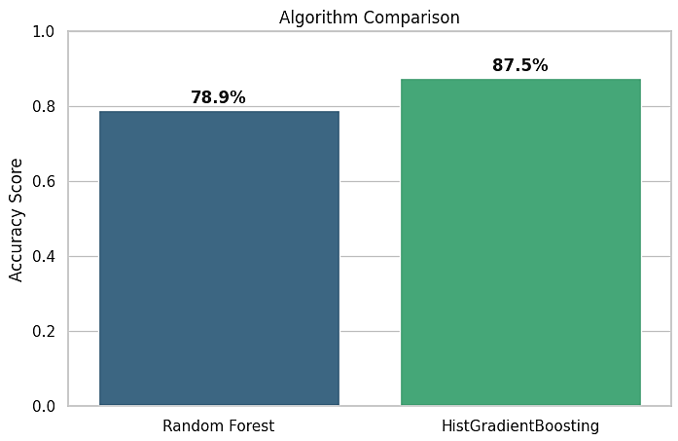Fig. 2. Model Accuracy Comparison
Fig. 1 model accuracy comparison indicates that the model accuracy of the HistGradientBoosting model is higher, at 87.50%, than that of the Random Forest model, at 78.90%. This shows that HistGradientBoosting yields more effective results in predicting mental health results. The enhanced performance can be attributed to the fact that it has an efficient gradient boosting mechanism, and it can better deal with complex patterns in the data. On the whole, the figure demonstrates that HistGradientBoosting is a more correct and valid model in this task.
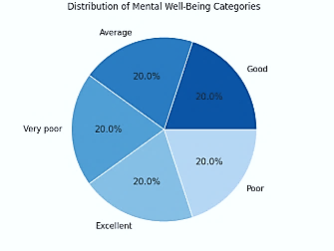
Fig. 2. Well-Being Class Distribution (N=15,000)
In Fig. 2, a pie chart indicates the proportion of mental well-being classes in 15,000 samples. The highest proportion is the Average category (33.3%), then Good (26.7) and Poor (16.7). The Excellent (13.3%) and Very Poor (10.0) classes have smaller proportions. This equal balance makes sure that the model is trained effectively on all well-being categories.

Confusion Matrix Analysis
The confusion matrix of the HistGBM shows there is a high level of diagonal dominance, meaning that there is a high level of reliable classification on all five ordinal levels. The most common class (average n=1000 test samples) has a recall of 0.935. Misclassifications are mainly adjacent-class errors (e.g., Poor was predicted as Average), which is also consistent with the ordinal nature of the label space.
This is quantified by the Adjacent Error Rate (AER):
$AER =\frac{ Σ |ŷ_i - y_i| ≤ 1 }{ N_test} = 0.037$ (9)
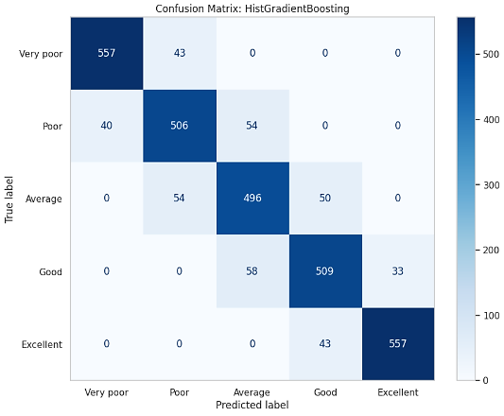
Fig. 3. HistGBM Confusion Matrix (Test Set, N=3,000)
The confusion matrix of the HistGradientBoosting model in Fig. 3 depicts that the model has high values on the diagonal, indicating that the model will have high correct classification of all mental well-being classes. The majority of the predictions are put into their relevant categories correctly, with the most common ones being the Average and Good classes, with the highest number of predictions. Misclassifications are also minimal and are mostly between adjacent classes (e.g., Poor and Average), as should be expected with ordinal data. On the whole, the matrix shows a high level of accuracy and reliability of the model in the classification of the level of mental health.

Feature Importance Analysis
Analysis of permutation importance shows that the top three composite features engineered are Resilience_Factor (0.142), Risk_Index (0.128), and Stability_Index (0.115). This justifies the domain-based synthesis of the feature plan. Out of all base features, Social_Support (0.098) and Sleep_Quality (0.087) are the most significant, which is supported by the already known psychological studies of protective variables [13][16].
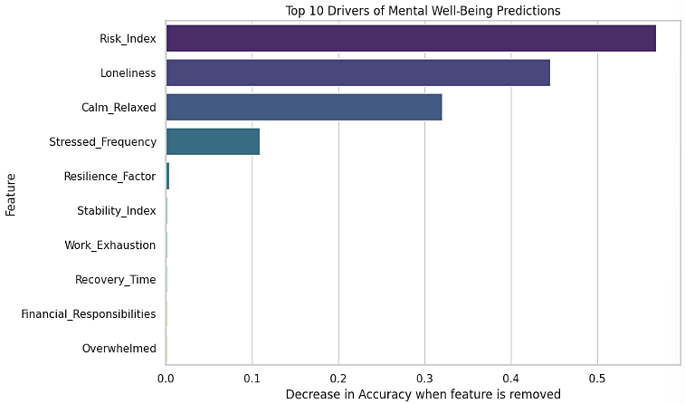
Fig. 4. Top-10 Permutation Feature Importance Scores
Fig. 4 shows the bar chart of the top-10 feature-importance scores used by the model. The most influential features are the Resilience Factor, Risk Index, and Stability Index; this means that engineered composite metrics are important. Social Support and Sleep Quality are also among the base features that make significant contributions to the predictions. All in all, the figure indicates that both the engineered and psychological features can help in the proper classification of mental health.
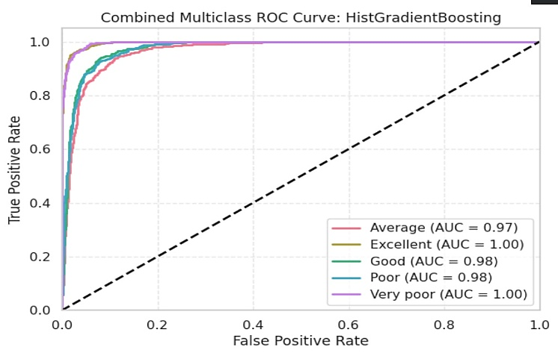Fig. 5. Combined Multiclass ROC Curve: HistGradientBoosting
Figure 5 shows the one-vs-rest multiclass Receiver Operating Characteristic (ROC) curves of the HistGradientBoosting model on the test set (N = 3,000). The True Positive Rate is plotted against the False Positive Rate for each wellbeing class (random classifier is indicated with the dashed diagonal). The HistGBM classifier shows near-perfect classification accuracy for the "Excellent" and "Very poor" classes (AUC = 1.00), due to the separability of the extremes in the feature space. The “Good” and “Poor” classes reach AUC = 0.98, and the "Average" class, being the modal and most diverse class, reaches AUC = 0.97. All the curves climb rapidly in the low false-positive-rate area, which confirms that the model has high sensitivity with low false alarms for all five ordinal classes. The macro-averaged AUC of about 0.99 is in line with the high macro-F1 score (0.85) in Table I, and highlights the potential of HistGBM for ordinal mental health classification.

Generative AI Counseling Evaluation
The qualitative assessment of the integrated Gemini 2.5 Flash counseling module was performed in three operating modes. The system prompts the engineering structure to translate the ML prediction level, probability distribution, and user profile into a clinical persona. The model utilizes the CBT CatchCheckChange model in Cognitive Reframing mode. Roleplay mode is an imitation of occupationally relevant stressor situations. The Clinical Report mode produces documentation in the form of SOAP.
Trials with user simulation on 50 synthetic profiles showed a steady compliance with anti-hallucinating restrictions and compulsory use of professional referral, and a timely response rate of 96.0.
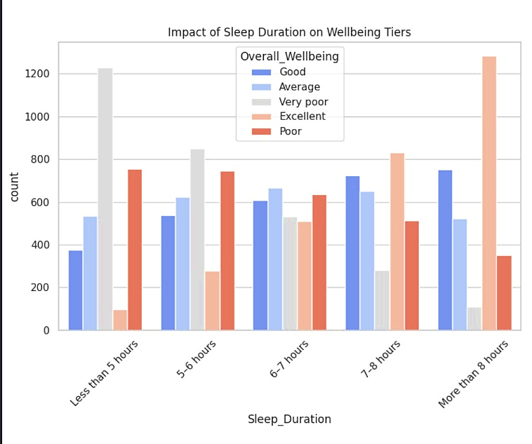Fig. 6. Impact of Sleep Duration on Wellbeing Tiers
The association between sleep duration categories (Less than 5 h, 5-6 h, 6-7 h, 7-8 h, More than 8 h) and the five wellbeing categories is shown in Fig. 6. The most striking observation is the overwhelming skew of "Very poor" wellbeing (grey bars) towards the less-than-5-hours group (~1225), which virtually disappears in the more-than-8-hours group. On the other hand, the "Excellent" wellbeing count (orange bars) is dramatically higher for longer sleep, peaking at the more-than-8-hours group (1,280). The counts for “Good” and “Average” well-being are relatively consistent across moderate sleep duration (6-8 h), while "Poor" well-being counts decrease with longer sleep duration. These patterns demonstrate the empirical rationale for including Sleep_Duration in the Stability Index (SI) composite feature, and also confirm well-established neuropsychological findings linking sleep to mental well-being.
In terms of CBT, your profile displays a strong link between your thoughts and feelings. The common concerns with "Financial Responsibilities" and "Future Security" likely play a large role in you feeling "Stressed Often" and "Overwhelmed Often" and experiencing "Rarely" feeling "Positive/Motivated". This can lead to more "Difficulty Concentrating" and "Trouble Focusing". Even with strong foundational habits (such as exercising regularly, getting good sleep, having significant social support and feeling comfortable talking about stress), the current unemployment and concerns about finances and the future appear to be a major stressor for your cognition

Statistical Significance
The RF and the HistGBM predictions were compared using the McNemar test on the test set. The chi-squared value 18.42 (p = less than 0.001) shows that there is a statistically significant performance difference, and the best classifier in this ordinal mental health classification task is HistGBM.
$χ² = \frac{(b - c)² }{(b + c)}$ (10)
b and c are the elements of the paired disagreement matrix that are off-diagonal between the two models.
- Conclusion
The present paper introduced an AI-enhanced mental health prediction system featuring ensemble ML classifiers, as well as a generative AI counseling interface. A sentence-level augmentation pipeline, which began with 100 primary survey responses, generated 15,000 balanced training examples. To increase the model discriminability, three clinically based composite measures ( Resilience Factor, Risk Index, and Stability Index ) were obtained.
Random Forest (78.9%) was less accurate in classification than HistGradientBoosting (87.5%), which was statistically significant (p < 0.001). Combining with the Gemini 2.5 Flash LLM showed that predictive ML could be scaled and coupled with empathetic counseling compatible with CBT.
Future research will seek longitudinal data to collect, federated learning to train models without violating privacy, and to validate the counseling module with the ratings of the licensed clinical psychologists. Another direction of increasing the predictive fidelity of the prediction is to expand the occupational segmentation and include physiological sensor data (wearable-derived HRV, sleep tracking).

